To all Church Recorder Members, Supporting Members and Friends of Church Recording Society CIO
THE FIRST ANNUAL MEETING OF CHURCH RECORDING SOCIETY
15 SEPTEMBER 2022
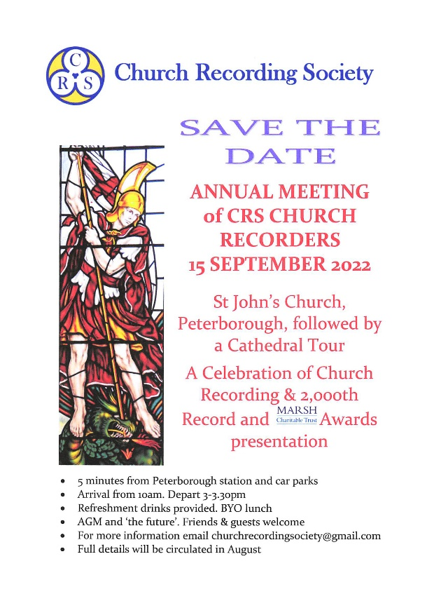 | The preliminary notice was widely circulated in July. There has been a very encouraging response. Now the details.  Church Recording has much to celebrate. First and foremost, the successful setting up of Church Recording Society CIO as the Members owned national society cementing the future of Church Recording and the re-awakening of Church Recording after the pandemic restrictions.  The 2,000th Church Record was completed in 2020. We will be marking that and other notable achievements.  The Marsh Awards for outstanding volunteering work will be presented by a Marsh Charity Ambassador.  We shall be looking to the future and within all this holding our first AGM.
This is an open meeting. Church Recorders are very much encouraged to come to enjoy the event and, in doing this, will be showing their appreciation for the huge commitment of the volunteers who have established Church Recording Society and its facilities. Friends, people and organisations who share our interest, representatives of Societies sponsoring Groups and partners are particularly welcome.

TIMETABLE
Thursday 15th September 2022
St John the Baptist’s Church, Church Street, Cathedral Square, Peterborough PE1 1XB [see ‘HOW TO GET THERE’ for sat-nav]
Arrivals from 10.00am. Start at 11.00am. Lunch break 1.00pm approx.
About 1.30 -2.00pm will start the Peterborough Cathedral Tours by Cathedral Guides, tailored to Church Recorders’ interests. £5 per person. The Cathedral is 5 minutes’ walk from St John’s. Tours are 1 hour. Personal effects may be left at St John’s at the owner’s risk until 3.30pm.
FACILITIES
Hot and cold drinks will be available from 10.00am until after Lunch. Biscuits until they run out. A celebratory glass of wine at lunchtime.
All free.
St John’s has many tables and chairs. It is ‘bring your own Lunch’. There are pubs and cafés in the immediate vicinity.
Good cloakrooms in St John’s. There are toilets off the Cathedral’s Nave.

HOW TO GET THERE
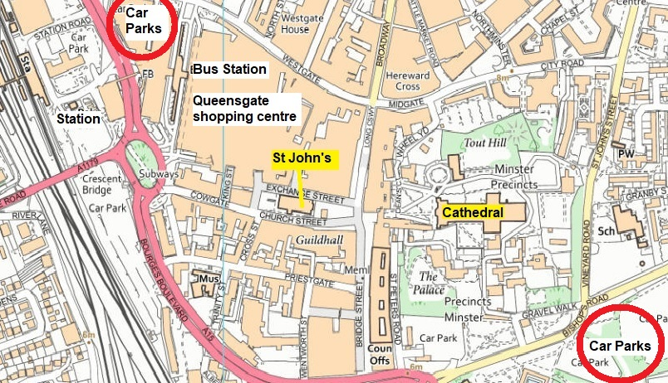

By rail to Peterborough Station. 5 minutes’ walk past Queensgate Shopping Centre.
By bus to Peterborough bus station. Walk past Queensgate Shopping Centre.
By car – Queensgate multi-storey car parks, sat-nav Bourges Boulevard PE1 1NT, are 5 minutes from St John’s, ringed red on map. 5 hours costs £5 and there is ample parking.
Off Bishop’s Road ringed red, nearest the Cathedral and 10 minutes from St John’s, Bishops Road sat-nav PE1 5AP and Riverside sat-nav PE1 1EG. 4 hours £5.50. ˃4 hours £6.50.

AGM
The AGM of Church Recording Society CIO takes place during the morning meeting. The formal business should be short because of the broader presentations and the opportunities for questions and discussion of the morning programme.
For the AGM documents (Notice of Meeting, Report & Financial Statements etc.) go to the Home page of the website https://www.churchrecordingsociety.org.uk/ and click on Notice of AGM at the top.
Church Recorders this is your opportunity to nominate any Recorder Member to join the Board of Trustees. We need more. The Board needs to be representative of Church Recorders and the average age reduced. This is essential for our future. There is a nomination form with the AGM documents. Alternatively, just contact churchrecordingsociety@gmail.com. We are saying this to you.

CATHEDRAL TOUR
You must, please, pre-book this with us because we have to commit to the Cathedral for the number of guides. It is a wonderful building. Binoculars recommended.
For this:
- To book - email churchrecordingsociety@gmail.com with your name and the name of anyone accompanying you; and either
- Remit £5 per person by internet bank transfer to the CRS dedicatedNatWest account: Mrs Elizabeth J Chalmers CRS Cash. Sort code 60-01-15. Account no 45609187.
- using as the Reference your surnameCath for example SmithCath;
- Or send a cheque payable to Church Recording Society to CRS AGM, c/o Green End, Rattlesden Road, Drinkstone, Bury St Edmunds IP30 9TN
as soon as possible and in any case to arrive by Tuesday 30th August.
Your booking will be confirmed, but only when the £5 has been received. This is not refundable because of the commitment to the Cathedral.

ATTENDANCE
Don’t be put off if you have been unable to say you are coming to the Event. BUT, it would help us considerably with catering, seating layout and name badges if you would email churchrecordingsociety@gmail.com to say you are coming and whether you are bringing anyone, please. Groups could do this through your Group Leader. If you have a good name badge already, bring that.

DISABLED ACCESS - good

FURTHER INFORMATION Email churchrecordingsociety@gmail.com

